**­­­**





|  |
| --- |
|  |
| **Name:** Syed Mohammad Raza Ali  **Enrolment no:** 028  **Faculty:** Mam Azeema Sadia  **Course:** Computer Programming Lab  **Assignment:** Lab-01 tasks  **Deadline:** 4 March-12am | |
|  | |

**Task 01**

Draw a flowchart of program to store statement record such as (Name, Age, Grade and CGPA). (0.5)

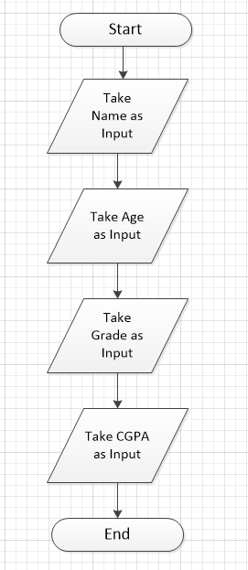

**Task 02**

Draw a flowchart program to read student’s three grade, calculate the average of the grade, and then display the average grade. (0.5)

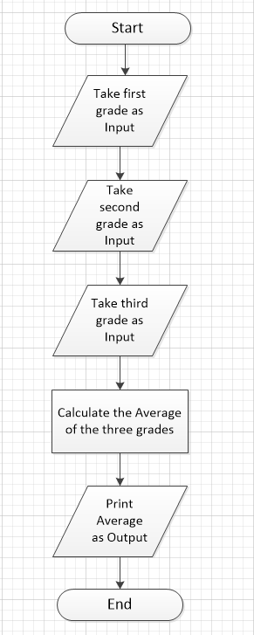

**Task 03**

Draw a flowchart that reads the height, length, and width of the rectangular box, Calculates and displays the volume.

Note: Volume = lwh. (01)

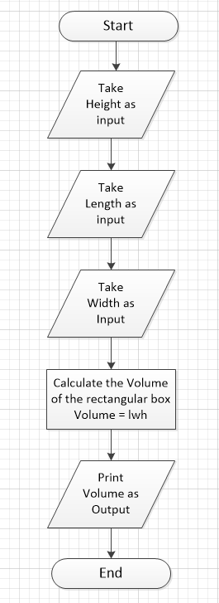

**Task 04**

Draw a flowchart of program to read the salary of an employee and prints particular designation of the concern person for example Manager Salary = 500k, Supervisor = 2.50k and

Technician = 120k. (01)

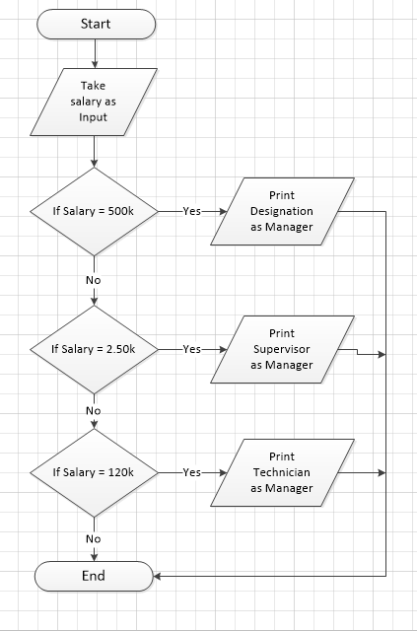

**Task 05**

Draw a flowchart of program to print grade for computer programming course.(01)

|  |  |  |
| --- | --- | --- |
| **Grades** | **Marks** |  |
| A | >80 marks |  |
| B | >70 marks |  |
| C | > 60marks |  |
| D | >40marks |  |

